WEEK 2

# Responsive Restaurant Website using HTML and CSS

Aim: To build a responsive Restaurant Website page

Languages used: HTML, CSS and JavaScript

Software Used: Visual Studio

This week we focused on using our HTML and CSS and java script skills for building a responsive restaurant website.

This time the coding and the website building complexity was a notch up. We included responsive elements and the website was just not a single page but consisted of multiple pages.

This project was almost completely what a official restaurant website would have. We included the menu, reservation option for booking a table and all details of the restaurant like the contact details etc.

My mentor Rocky Sir helped a lot in the queries and errors during the project building. He played an important role solving my errors which were a lot more than last time.

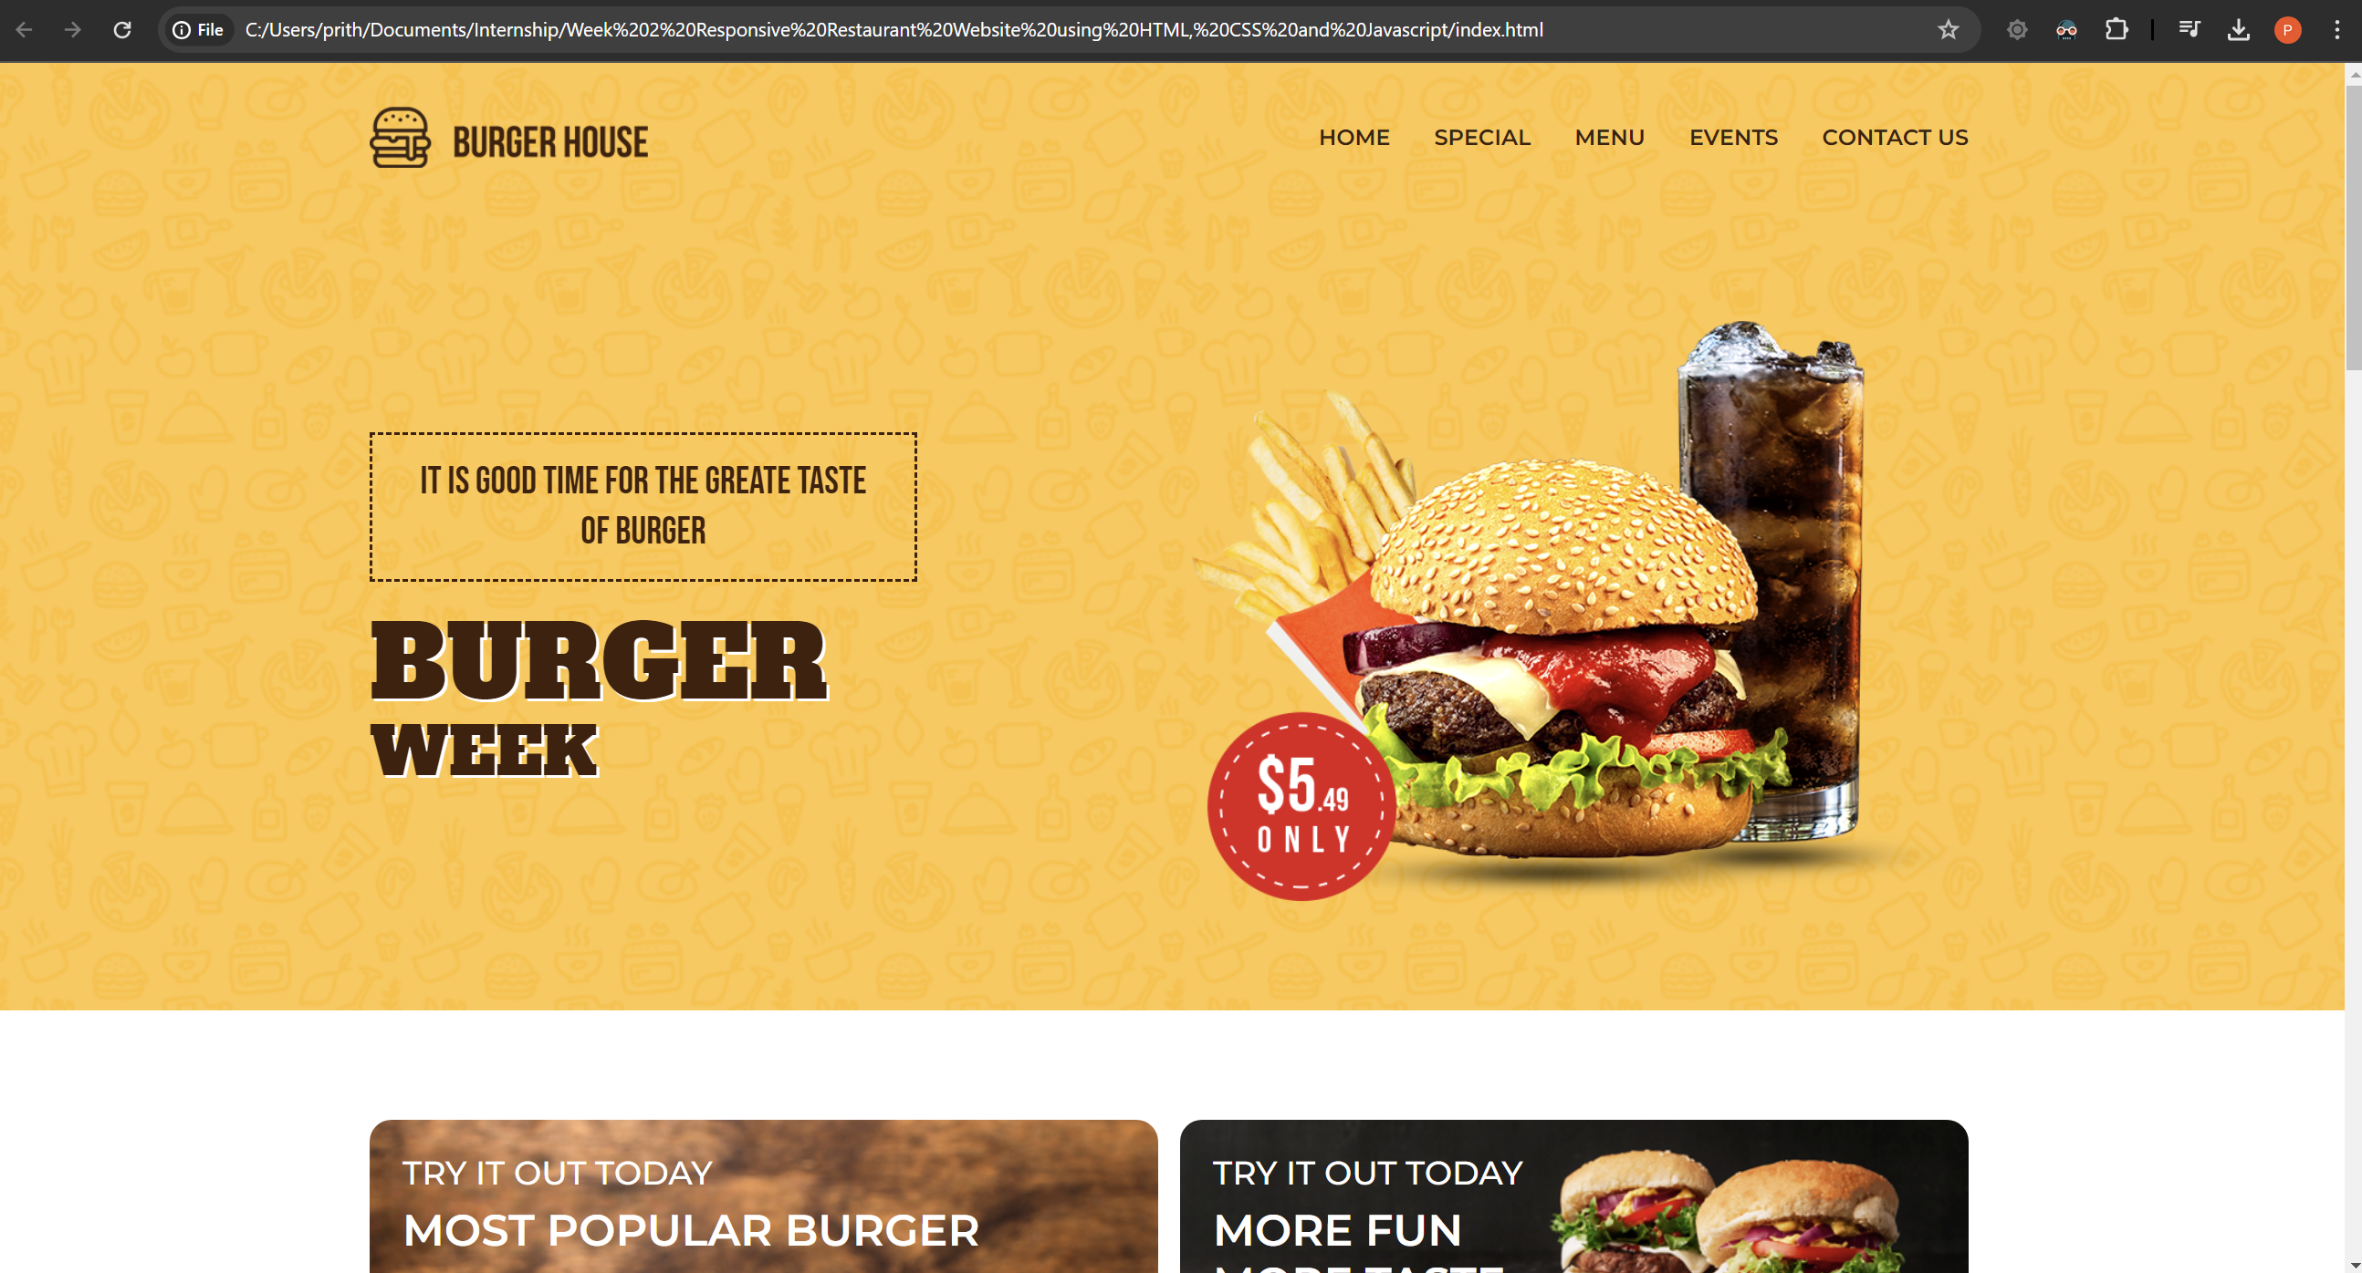

This is a screenshot of the starting page of the website. The burger picture and the title BURGER WEEK have animation added to them and come sliding in on loading the website.

We could do any choice of restaurant I chose to go with just a burger restaurant.

The titles on top like Home, special, menu all turn red when you hover over them.

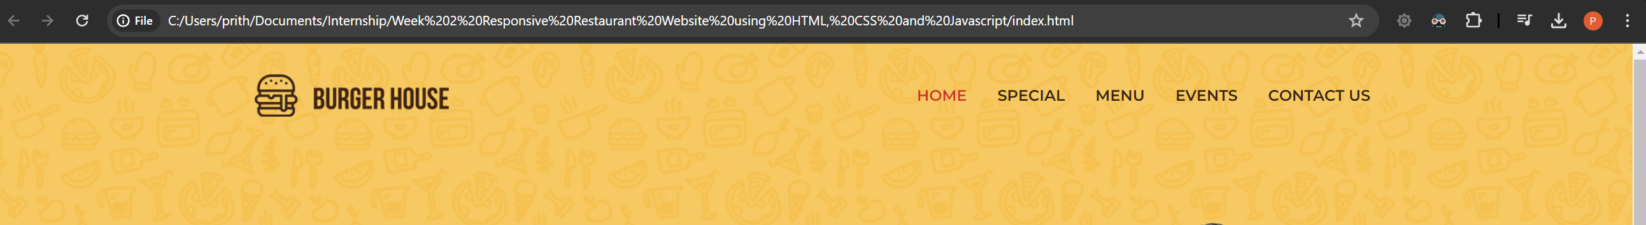

And when clicking on each of them it takes you to the respective section of the website which is a convenient feature for the customer.

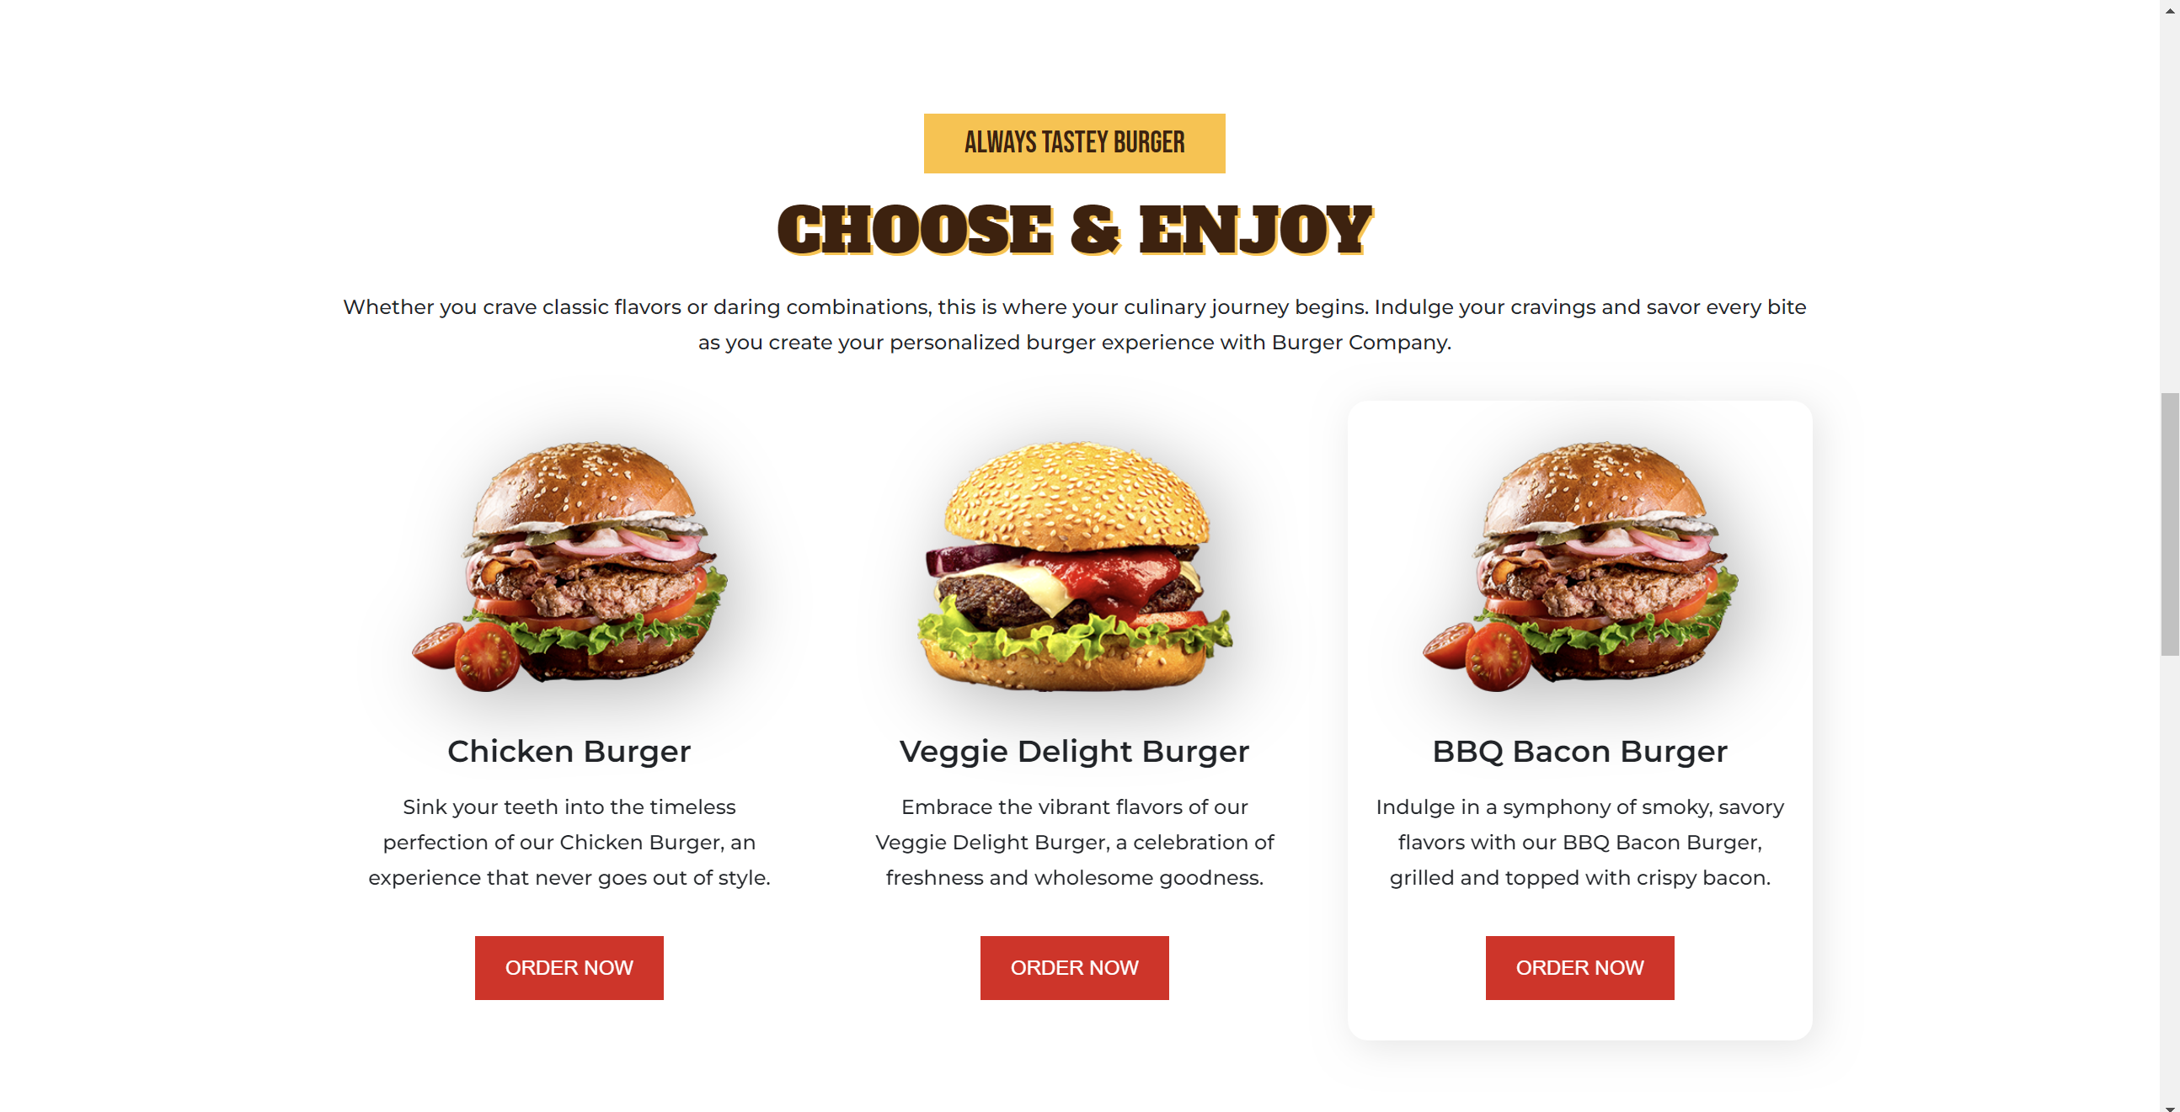

The menu section is also responsive as you can see when hovering the cursor over the choice of burger which is the third one in my case the panel behind becomes visible and feels like the panel has an animation of popping up.

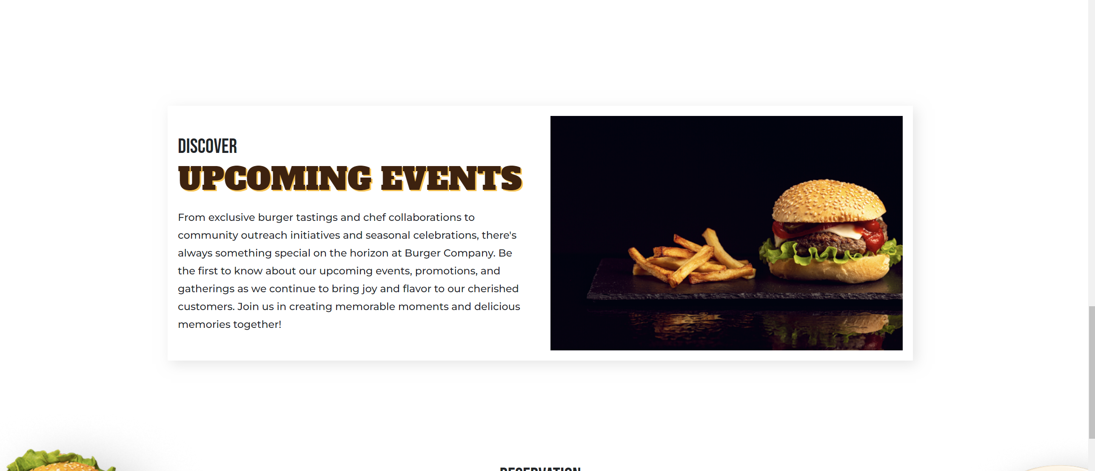

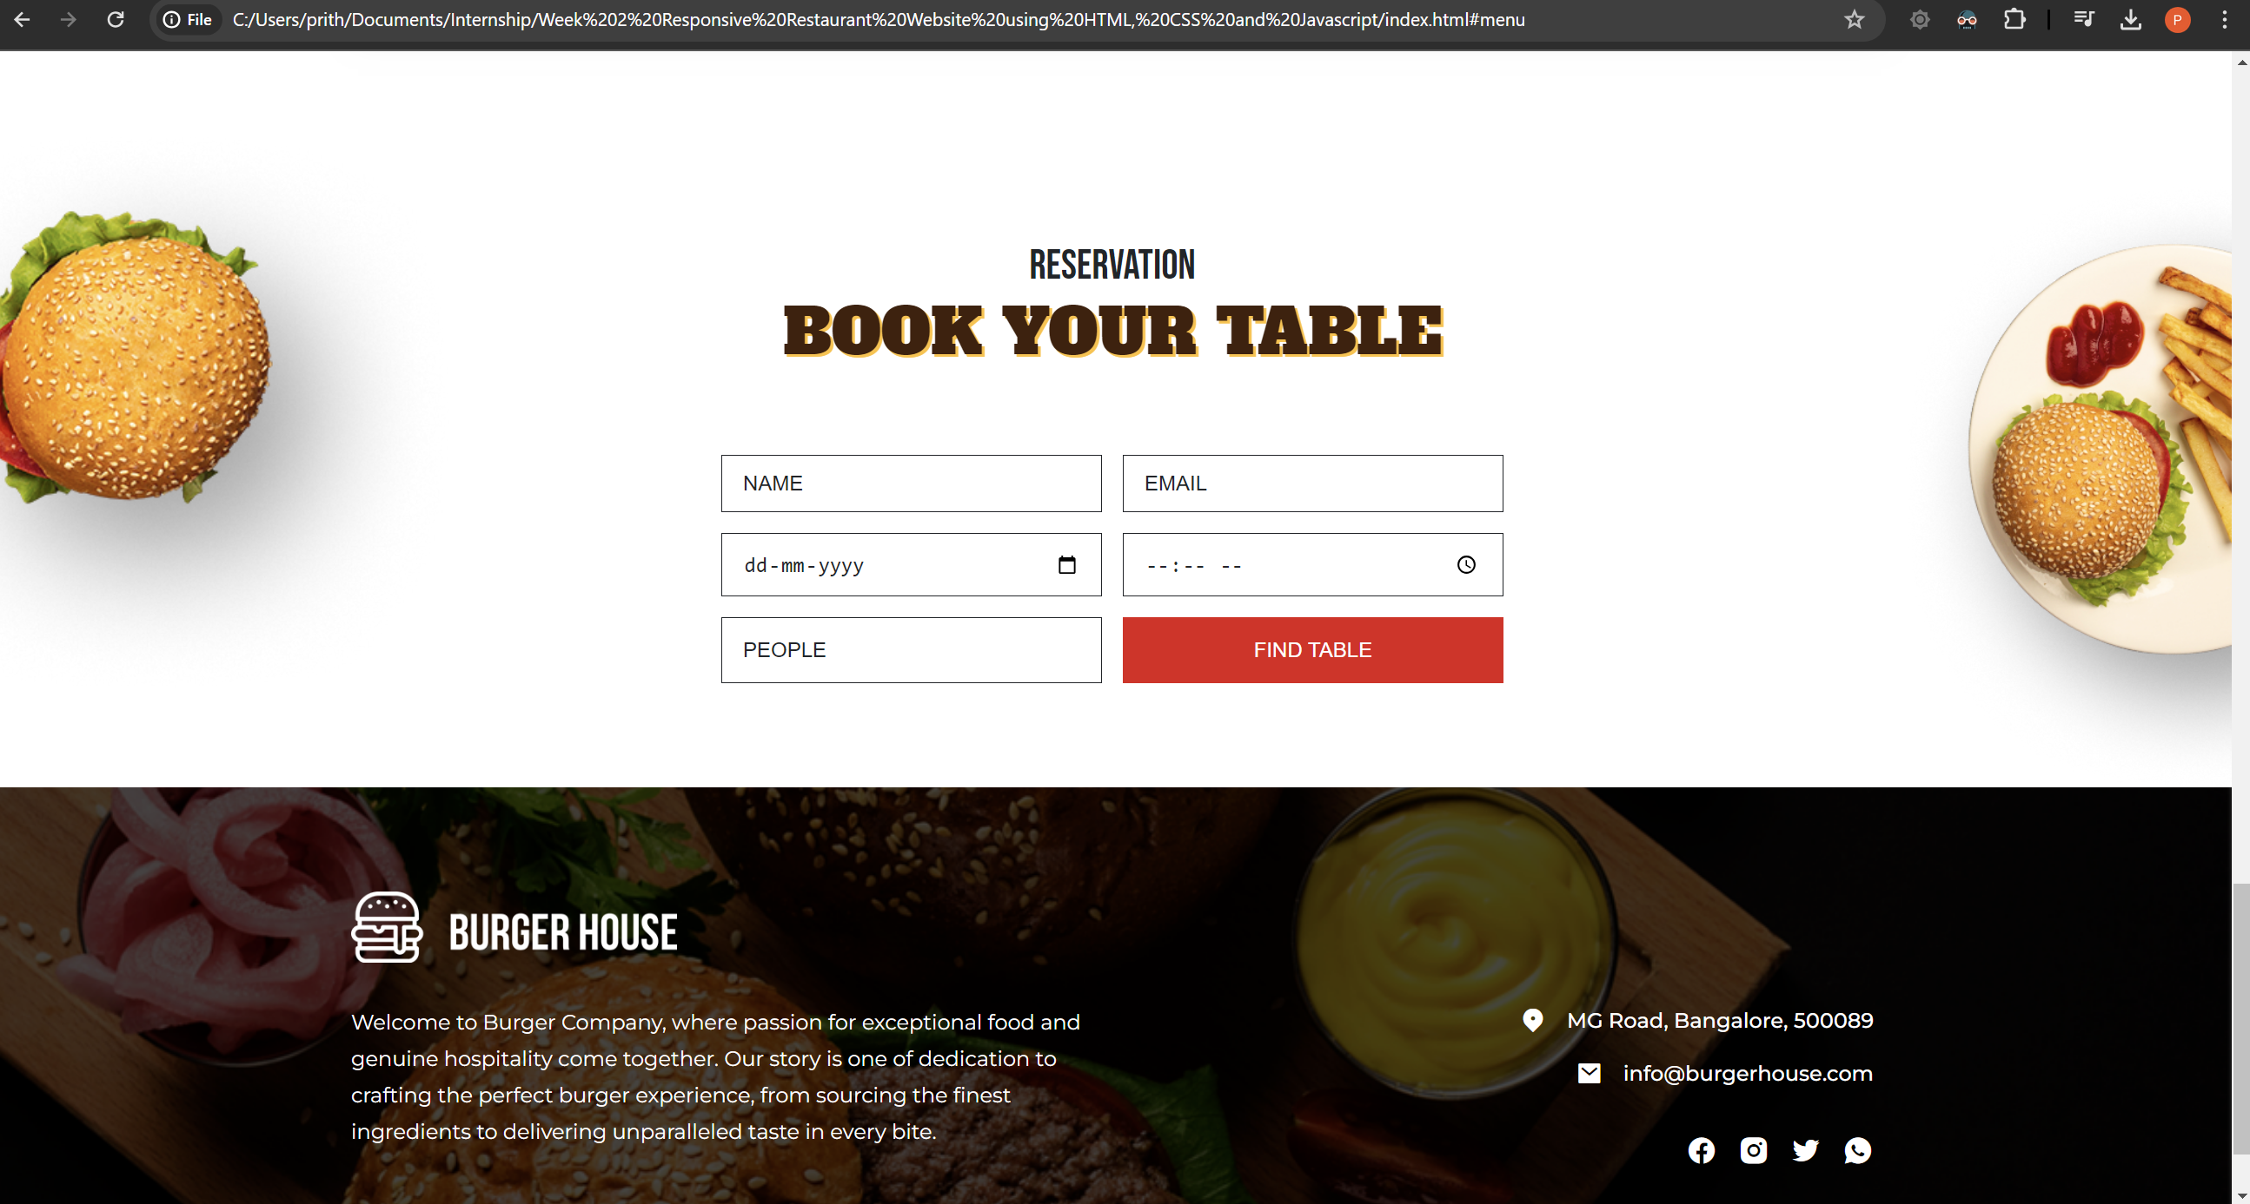

This section of the website is for reserving a table at the offline location of the restaurant. It takes the name, email, DOB and a few other information of the customer.

The last section of the website is information of what the restaurant is about and the location and contact details and other social media platforms identification.

The code and all elements used has been uploaded separately in a folder in the drive.